Group Challenges Ban on Women's Torah Reading at Western Wall
Center for Women’s Justice files petition to High Court, claiming that ban on women reading from Torah scrolls at Western Wall violates anti-discrimination laws.
Judy Maltz Nov 29, 2015 6:35 PM
A group of feminist activists is challenging the legality of denying women access to Torah scrolls at the Western Wall.
In a petition filed with the Israeli Supreme Court on Sunday, the group argues that denying them access to Torah scrolls violates their right for equal treatment in the public sphere. The petition also claims that Rabbi Shmuel Rabinowitz, the chief administrator of the Western Wall, has no legal authority to issue such a ban, and it must, therefore, be annulled.
The petition was filed by the Center for Women’s Justice in Jerusalem on behalf of four members of an organization known as Original Women of the Wall. This organization split off from Women of the Wall a few years ago in protest at its board’s decision to negotiate with the government the possibility of moving the group’s monthly prayer service from the women’s section of the Western Wall to a still-to-be-created egalitarian prayer space nearby.
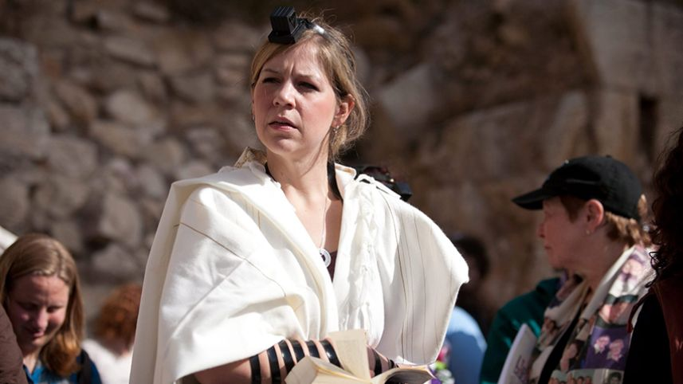Women of the Wall praying at the Western Wall. Credit: Michal Fattal
Rabinowitz, who also serves as director of the Orthodox-run Western Wall Heritage Foundation, issued a directive in 2010 that prohibits visitors to the holy site from bringing in their own Torah scrolls with them. The men’s section of the Western Wall has dozens of Torah scrolls available for the use of male worshippers.
Unlike the Reform and Conservative movements, ultra-Orthodox Judaism restricts reading from the Torah scroll to men, and Rabinowitz has repeatedly rejected requests by women’s groups to borrow scrolls from the men’s section for the purpose of conducting their own readings. For this reason, according to the petition, Rabinowitz’s directive discriminates against women in the public sphere.
In a separate action, the Center for Women’s Justice also filed a suit in the Jerusalem Magistrate Court demanding damages of NIS 150,000 for being denied access to the Torah scrolls at the Western Wall on three separate occasions and in violation of the law that prohibits discrimination in public places.
In an email to Haaretz, Rabinowitz wrote that negotiations are ongoing to create the adjacent egalitarian space where non-orthodox groups will be able to hold mixed prayer services. He said this is the solution that should be pursued and criticized the petitions seeking to change the rules at the Western Wall plaza itself.
"We should not solve one problem while lighting a fire in another spot," he wrote.
Susan Weiss, the director of the Center for Women’s Justice, called the directive issued by Rabinowitz “one example of what happens when the state cedes its authority to theocratic bodies that do not believe in human rights or equality under the law.” She said the law does not provide the administrator of the Western Wall with the authority to prevent women from reading from a Torah scroll on the premises. “This is a case of regulatory overreach,” she said.
Women’s groups have in the past year succeeded in smuggling Torah scrolls into the women’s section, despite the ban. In several instances, when caught, they have been detained by police.
“Bringing in our own Torah scrolls has required subterfuge, and that’s ridiculous,” Shulamit Magnus, a professor of Jewish history and one of the backers of the petition, told Haaretz. “We believe there are profound legal implications for this suit on the matter of equal treatment in the public sphere.”
Two weeks ago, Rabinowitz also rejected a request by Women of the Wall to have women included in the official state-sanctioned Hannukah candle-lighting ceremony at the wall.
In a jointly written statement, the plaintiffs explained: “We take no pleasure in the need to take this action; it is a sad commentary on the state of religious politics that it is needed. But having been denied, defamed, denigrated, manipulated, and patronized for years, it is high time to assert our rights openly and proudly, as Jews, as women, and as Israelis. And we do.”
Ever since the Jerusalem District Court ruled in April 2013 that it is not a violation of “local custom” for women to wear prayer shawls and pray out loud at the Western Wall, as Rabinowitz had claimed, there have been no arrests of women for engaging in these practices. But through the directive he issued in 2010, noted Magnus, Rabinowitz has been able to prevent women from reading from the Torah at the Western Wall.
read more: http://www.haaretz.com/jewish/news/.premium-1.689041

